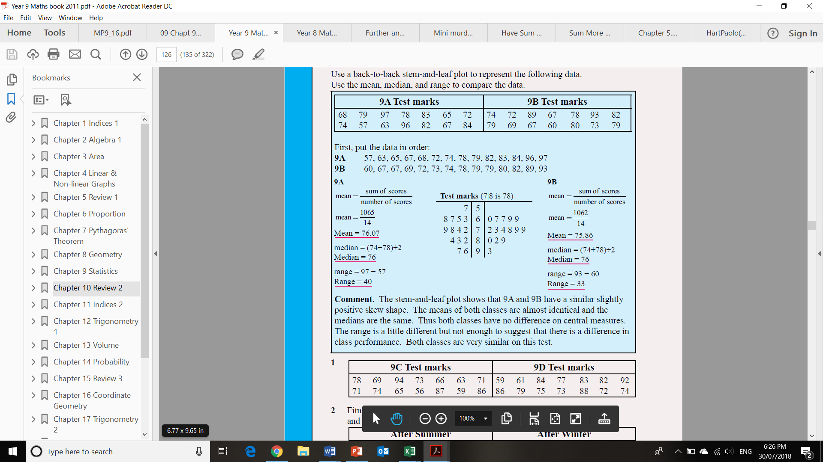
Stem and leaf example

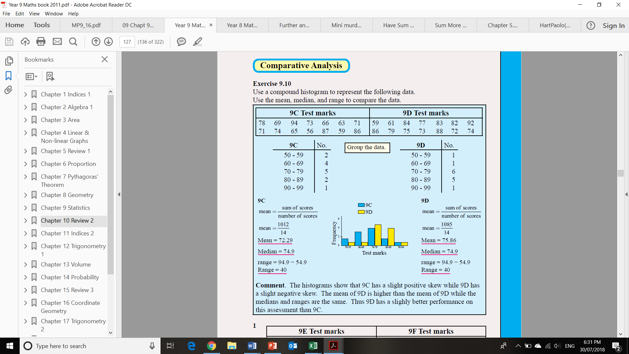
Mean:

Median:

Range:
Mean:

Median:

Range:
Histogram example
Mean:

Median:

Mode:
Range:
Mean:

Median:

Mode:
Range:

